GAS BAIN MARIE INSTRUCTIONS
MODEL: INGB-3G / INGB-4G / INGB-44 / INGB-66 / INGB-60
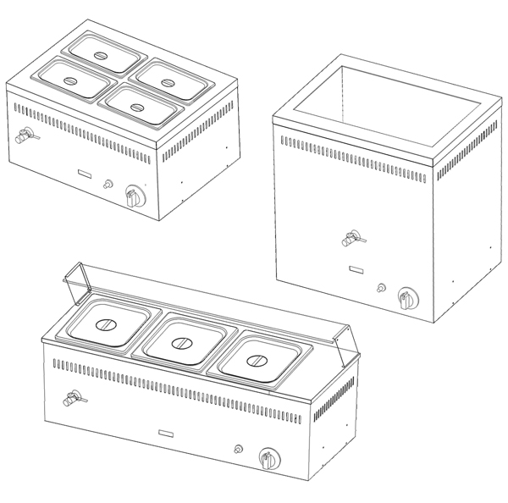
SAFETY INSTRUCTIONS
INSTALLATION INSTRUCTIONS
OPERATION INSTRUCTIONS
MAINTENANCE INSTRUCTIONS
REPLACING FAULTY COMPONENTS
TECHNICAL DATA
EXPLODE
PARTS LIST
WARRENTY INFORMATION
FOR THE PURPOSES OF THIS DOCUMENT,THE FOLLOWING TERMS AND DEFINITIONS APPLY.

SAFETY INSTRUCTIONS

IMPORTANT, PLEASE READ INSTRUCTIONS FULLY BEFORE USE

THIS APPLIANCE IS ONLY FOR PROFESSIONAL USE AND MUST ONLY BEUSED BY QUALIFIED PEOPLE.

Attention should be drawn to the fact that parts of this unit by necessity, will get VERY HOT, and will cause burns if touched accidentally. Therefore it is the responsibility of the supervisor or equivalent to provide SUITABLE PROTECTIVE CLOTHING for the user.

THIS APPLIANCE MUST BE FITTED AND TESTED BY A REGISTERED FITTER BEFORE USE.

The unit should be installed in compliance with the INSTALLATION

INSTRUCTIONS and the NATIONAL REGULATIONS in force at the time.
Particular attention should be paid to the Gas Safety (Installation and Use)
Regulations and the Health and Safety at Work Act.

Each appliance requires a flow of fresh air for combustion. Under no circumstances should air vents on the appliances, or air vents installed by the fitter in the room of the appliance to supply combustion air, be altered or omitted in any way.

To prevent shocks, all appliances whether gas or electric, must be earthed.

ANY GAS CONVERSIONS NEEDED TO BE MADE TO THE PRODUCT MUST BE CARRIED OUT BY A QUALIFIED REGISTERED ENGINEER

To avoid scratching the highly polished exterior surface of this equipment whilst in transit, the protective film on the exterior surfaces has NOT been removed. It is IMPORTANT that this protective film is peeled off before the equipment is used.

FOR THE PURPOSES OF THIS DICUMENT,THE FOLLOWING TERMS AND DEFINITIONS APPLY.

The products stated above are designed and built to comply with the following standards:
BS EN 203-1:2005
BS EN 203-2-9:2005

The products have been CE-marked in compliance with the European Gas Directive (2009/142/EEC)

INSTALLATION INSTRUCTIONS
ALL APPLIANCES MUST BE FITTED AND OR CONVERTED BY AREGISTERED INSTALLER, IN ACCORDANCE WITH CURRENT REGULATIONS.

INSTALLATION
1. Appliances are designed to be installed, on DRUMMOND TRADE LTD for stability,
should they be fitted on any other surface they should be suitably secured, to prevent excessive movement. All appliances must not be installed on or against any combustible surface.
2. Appliances are supplied in for use with either Natural Gas or LPG. The required gas type must be
specified at the point of order. If you want to change the source gas.You can buy the conversion kits and change it by professional engineer.
3. Clearances around appliances must be:
1）. CEILING/SHELF 1500mm
2）. REAR 350mm
3）. SIDES 100mm
It should be noted that the sides of the appliance will get hot and appliances with components
sensitive to heat, should not be placed directly next to the unit.
4.Leg Installation see picture at down, The leg channel is located on the package base. This channel must be installed when using the legs.

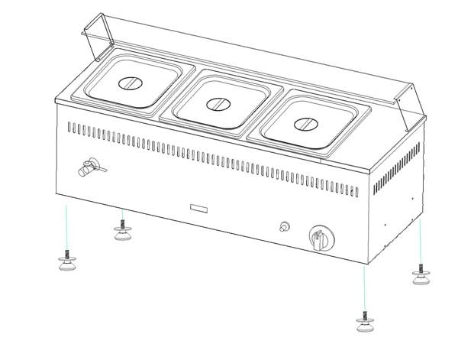
5. Connection to the appliance is by ½ BSPT at the rear of the appliance.
6. Pressure test point is located at rear of appliance.
7. The low rate adjuster is factory set and sealed for natural gas. If a unit needs to be converted,the qualified engineer must reseal the low rate adjuster after conversion.
8. Remove all protective film before use.
9. Ensure whoever is operating the appliance is fully conversant with its operation and aware of dangers involved in incorrect operation and cleaning, especially the danger of burns or scalds from the cooking medium and hot surfaces of working areas.
10. These appliances are to be installed with sufficient ventilation to prevent the occurrence of unacceptable concentrates of substances harmful to health in the room in which they are installed.
11. During installation provision must be made for combustion air supply to the appliance, which enters the appliance through the base and rear of the appliance, this should not be blocked at any time. SEE TECHNICAL

OPERATING INSTRUCTIONS
FOR FITTING INSTRUCTIONS SEE INSTALLATION SECTION.
ALL BAIN MARIE ARE FITTED WITH FLAME FAILURE DEVICE FOR SAFETY AND SPARK IGNITION FOR EASE OF LIGHTING TO LIGHT BURNER:
- Add water into the tank before use.
- Use your left hand to push in the tap and turn it anti-clockwise to position”  ”.
- Holding the tap fully in,use your right hand to depress the red ignitor button on the right side and observe that the pilot lights.If it does not,repeatedly depress the ignitor button until it does.
- When the burner is lit,continue to hold the tap in for about 15 to 20 seconds,then release it.
- If it still couldn’t light after one minutes, then turn the tap back to position ”●”. Wait for 5 minutes,then repeat from step 1~3.
- When you use this appliance at the first time, there will be air inside the air inlet pipe, which may result in the failure in ignition. Ignite again in the above-mentioned way until it is successful.
- The fire is the most power when the switch of the appliance is turn to 90. When it is turned to greater or less than 90, the fire will gradually reduce.
- After use, turn the switch of the appliance clockwise until a ticking sound is heard and turn off the control valve of the liquid gas storage tank.

MAINTENANCE INSTRUCTIONS
- MAINTENANCE:
- The appliance can be clean with a soft cloth after use, and be wiped with neutral detergent if necessary.
- The residual oil collected in the oil container on the top of the cabinet should be cleaned up regularly.
- Be sure not to wash the appliance with water.
- The appliance should be cleaned kept in well-ventilated place without corrosive gas if it will not be used for a long period of time.
  - When using the appliance, be sure not to touch the hot plate with hands to avoid scald due to high temperature.
6 When the appliance is not in use, turn off the gas supply valve to avoid accident. In case of breakdown, be sure not to disassemble the appliance by yourself. Please send it to the special repair shops or the dealers of our company for repair.

- WARNING:
- This appliance used low-pressure control valve for gas supply. The use of high-or medium-pressure valves is prohibited.
- Be sure not to wash the appliance with water! Otherwise, the gas device may have problems due to damp.
- Placement of inflammables or explosives in the cabinet or around the appliance is strictly prohibited!
- When the work is done, turn off the switch and the gas supply valve of the appliance immediately!

REPLACING FAULTY COMPONENTS
- Diagnosis of Common Fault:
Fault | Cause Analysis | Solution
Failure  in ignition | - There is no gas supply or the gas pressure dose not fit.  - The valve of the appliance is damaged.  - The ignition electrode has loosened and shifted. | 1. Check the air inlet and the gas pressure.  2. Replace the valve of the appliance.  3. Adjust the position of the ignition electrode and make it firm.
The fire goes out immediately after successful ignition | - The fire detector has dislocated or the lead has dropped.  - Lack of oxygen for combustion  - The gas pressure is too low or the gas supply is insufficient. | 4. Adjust the fire detector to allow the flame to go red.  5. Maintain good ventilation.  6. Check and replace the gas, or turn up the gas supply valve.

The above types of faults are for reference only. In case of fault, stop using the appliance immediately and contact professional maintenance workers for repair or contact the supplier as possible.

TECHNICAL DATA
SHEET 1
MODEL | BURNERS | Capacity | PRODUT SIZE  (WxDxH) | REMARK
INGB-3G | 1 | 1/2 x 6” x 3 | 955x365x345mm | With glass dustproof cover
INGB-4G | 1 | 1/2 x 6” x 4 | 1220x365x345mm | With glass dustproof cover
INGB-44 | 1 | 1/4 x 6” x 4 | 590x430x350mm
INGB-66 | 1 | 1/4 x 6” x 6 | 870x430x350mm
INGB-60 | 1 | 1/1 x 6” x 1 | 590x430x650mm

SHEET 2
MODEL | BURNERS | HEAT INPUT (KW)
MODEL | BURNERS | I3+(28~30/37) | I3B/P(30) | I2H(20)/I2E(25)
INGB-3G | 1 | 3.3 | 3.3 | 3.3
INGB-4G | 1 | 3.3 | 3.3 | 3.3
INGB-44 | 1 | 3.3 | 3.3 | 3.3
INGB-66 | 1 | 3.3 | 3.3 | 3.3
INGB-60 | 1 | 3.3 | 3.3 | 3.3
Inlet pressure (mbar) |  | 28-30 | 30 | 20
Injector orifice (mm) |  | 0.88 | 0.88 | 1.3
Destination countries |  | BE, CH, CY, CZ, ES, FR, GB, GR, IE, IT, LT, PT, SI  SK | BE, CY, FI, FR,  GB, GR | AT, CH, CZ, DK,  EE, ES, FI, GB,  GR, IE, IT, LT,  LV, NO, PT, RO,  SE, SI, SK
Complied standard |  | EN203-1:2005 Gas Heated Catering Equipment-Part: General Safety Rules.
This appliance shall be installed in conformity with the current regulations and used only in a well-ventilated location. Consult the instructions before installing and using this appliance.

EXPLODE
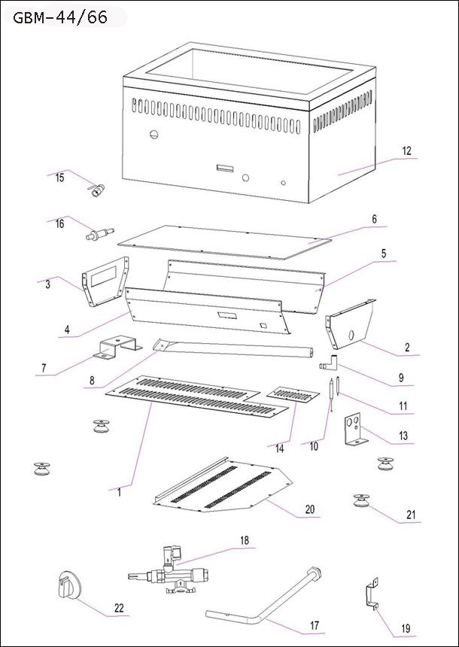
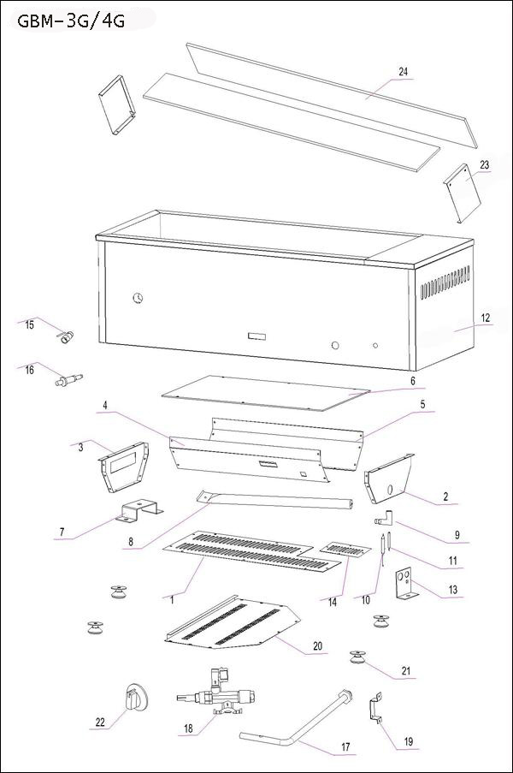
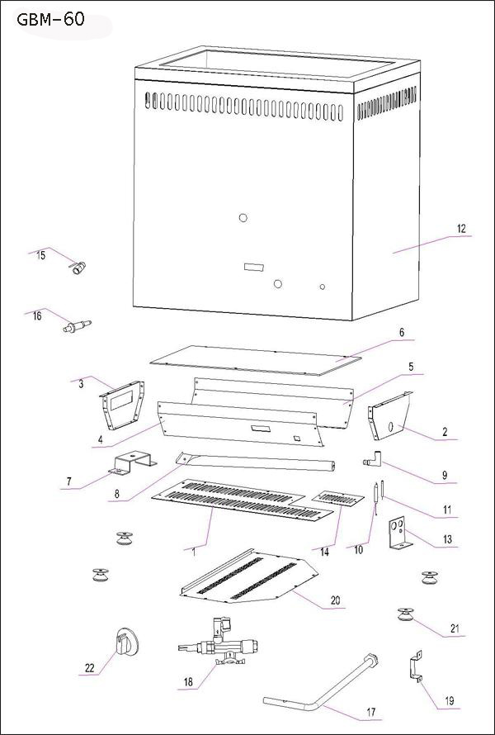
PART LIST

NO. | PART | QUANTITY / MODEL |  |  |  |  | Remark
NO. | PART | GBM-3G | GBM-4G | GBM-44 | GBM-66 | GBM-60 | Remark
1 | Base plate of firebox | 1 | 1 | 1 | 1 | 1
2 | Front plate of firebox | 1 | 1 | 1 | 1 | 1
3 | Back plate of firebox | 1 | 1 | 1 | 1 | 1
4 | Left plate of firebox | 1 | 1 | 1 | 1 | 1
5 | Right plate of firebox | 1 | 1 | 1 | 1 | 1
6 | Heat transfer plate | 1 | 1 | 1 | 1 | 1
7 | Fixed plate for burner | 1 | 1 | 1 | 1 | 1
8 | Burner | 1 | 1 | 1 | 1 | 1
9 | Injector | 1 | 1 | 1 | 1 | 1
10 | Thermocouple | 1 | 1 | 1 | 1 | 1
11 | Igniter | 1 | 1 | 1 | 1 | 1
12 | Body | 1 | 1 | 1 | 1 | 1
13 | Holder for Igniter | 1 | 1 | 1 | 1 | 1
14 | Cover plate | 1 | 1 | 1 | 1 | 1
15 | Drain valves | 1 | 1 | 1 | 1 | 1
16 | Piezo lgniter | 1 | 1 | 1 | 1 | 1
17 | Inlet pipe | 1 | 1 | 1 | 1 | 1
18 | Gas control valve | 1 | 1 | 1 | 1 | 1
19 | Holder for inlet pipe | 2 | 2 | 2 | 2 | 2
20 | Base plate of body | 1 | 1 | 1 | 1 | 1
21 | Legs | 4 | 4 | 4 | 4 | 4
22 | Knob of valve | 1 | 1 | 1 | 1 | 1
23 | Holder for glasses | 2 | 2 | / | / | /
24 | Glasses | 2 | 2 | / | / | /
25 | Fixed pole for Glasses | 2 | 2

WARRENTY INFORMATION
WARRANTY POLICY
• All service calls will be carried out between the hours of 8.00am 5.00pm Monday to Friday only.

• We accept no responsibility for delays in replacing or repairing the equipment due to circumstances beyond our control.

• Your warranty can be immediately invalid if the installation of the equipment has not been installed in accordance with the manufactures instruction. (See installation details). Also the miss-use, alteration or unauthorised repairs of the equipment will invalidate the warranty.

• During the warranty period it is at DRUMMOND’s discretion to repair or replace the equipment.

• Warranty only applies if the equipment has been used in a professional manor following the manufactures instructions and maintenance guide lines.

• The warranty covers defects in the material and components failure only we are not liable for trading loss, loss of perishable items, water damage, loss due to injury or fire damage.

WARRANTY REQUEST
• Please ensure you have referred to the manufacturers instruction before placing a warranty call. Or contact our warranty department on 0044 7979686094 for technical assistance. Please ensure you obtain the model number before calling.

• Please ensure you have read the section not covered under warranty to avoid any unnecessary warranty charges.

• If the problem with the machine can not be resolved please contact the company that supplied you the machine.

(SERVICE CALLS CAN DIRECT WITH DRUMMOND)

NOT COVERED UNDER WARRANTY
• Fault due to poor maintenance.
• Resetting of equipment
• Abuse of the equipment
• Blockages eg, drains, burners, pipes etc
• Lime scale related issues
• Installed incorrectly
• Access arranged for service call and engineer refused access or customer not there.
• No faults with the machine.
• Excessive carbon build up on griddle plates.
• Any damages caused by the customer.

All of the above are not covered under our warranty policy. Any costs incurred because of the above will be forwarded to the parties responsible for placing the call.

Failure to pay any warranty charges will result in the customers warranty been put on hold until the bill has been settled.

Any issues regarding the raised charges should be put in writing to our warranty department for further investigation.

