INF-HC Series
FOOD WARMER CART
User Manual
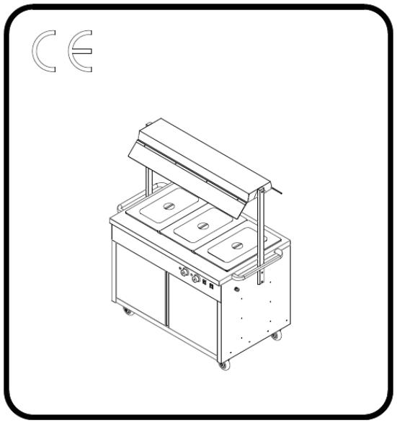

Please read this user manual carefully before operating this equipment.

Scope of Supply
The actual product you receive may sometimes differ from the descriptions and illustrations in this manual. This can occur for a few reasons:
Special Configurations: If your product has a unique design or specific customization, its features may vary from the standard description.
Optional Features: Any additional options or upgrades you've chosen will, of course, be included in your product, leading to differences from the basic model described.
Technological Advancements: We continuously work to improve our products. Due to rapid changes in technology, newer, enhanced components or designs may be incorporated, even if they aren't yet reflected in this manual. These changes are always made to provide you with the best possible product. If you have any questions, please contact the manufacturer.
In order to give you the best performance of this product and reduce unnecessary losses and injuries, please read the operation guide carefully before starting any operation on the device, especially before starting the device!
The manufacturer is not liable for any damage or negligence caused by non-compliance with the operational guidelines.
Warning
1. Any modification, incorrect installation, adjustment, repairs, or maintenance may result in property loss or casualties. If necessary, the modification or maintenance should be
liaised with the supplier and carried out by trained professionals；
2. For your safety, please do not store or use flammable and explosive gases, liquids, or articles near this product；
3. The equipment shall not be used by persons with physical, perceptual, or psychological disabilities, or lack of experience or knowledge (including children), unless someone supervises their safety or gives instructions on how to operate the device；
4. Please monitor children to ensure that they do not play with the equipment.
5. Please be careful to store operating instructions. All users of the device must adhere to the operating instructions and safety guidelines.
6. Flammable and explosive gases, liquids, or articles should not be stored or used near usage areas.
7. If appliances are located close to walls, partitions, kitchen equipment, and trim panel, it is recommended that the equipment and facilities are made of non-combustible materials, otherwise they should be covered with appropriate non-combustible insulation materials, and pay close attention to fire protection regulations.

Catalog

Ⅰ. Product Profile 4

Ⅱ. Basic Parameters 4

Ⅲ. Symbols Description 4

IV. Working Principle 5

Ⅴ. Notes 6

Ⅵ. Operating Instructions 6

Ⅶ. Routine Check 7

Ⅷ. Maintenance and Cleaning 7

Ⅸ. Diagnostics, Common Faults 8

Ⅹ. Packing List 8
Ⅰ. Product Profile
The YH Series Food Warmer features a sleek, popular design with a high-quality stainless steel body, making it both luxurious and hygienic. It uses energy-efficient and safe electrical components from reputable manufacturers. With its built-in thermostat, operation is straightforward. The YH Series Food Warmer is a versatile, top-quality unit, perfect for hotels, bars, restaurants, and fast-food establishments.
Ⅱ. Basic Parameters
Model | Rated  voltage | Rated  power  (kW) | Capacity of water box | Product  size(mm) | N.W.  (kg) | Remark
INF-HC88 | 230V~50Hz | 2.65 | 1*1/1*150mm+2*1/2*150mm | 880*690*870 | 50 | Wet burning
INF-HC121 | 230V~50Hz | 2.65 | 1*1/1*150mm+2*1/2*150mm+3  *1/3*150mm | 1215*690*870 | 68 | Wet burning
INF-HC155 | 230V~50Hz | 2.65 | 2*1/1*150mm+2*1/2*150mm+3  *1/3*150mm | 1550*690*870 | 86 | Wet burning

Ⅲ. Symbols Description

In this specification, symbols are used to highlight all important safety instructions and recommendations related to equipment. In order to avoid accident risk, casualties or property losses, please follow these instructions with special care.

Equipotential


Ground Wire

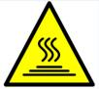

Caution Hot
IV. Working

Principle

YH2W1/YH3W1/YH4W1

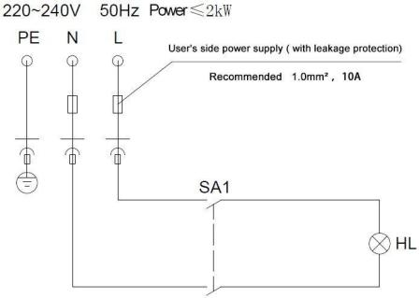

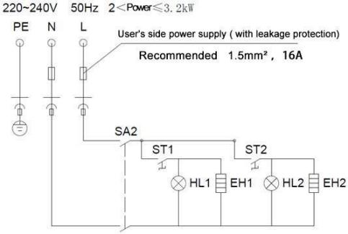

SA1: Tungsten lamp switch HL: Tungsten lamp
SA2: Working switch
ST1、ST2: Temperature controller HL2: Heating Indicator EH1、EH2: Heating Pipe
Ⅴ. Notes
Important Safety Information
- User Suitability: This appliance isn't intended for use by individuals with reduced physical, sensory, or mental capabilities, or those lacking experience and knowledge, unless they are supervised or have been given instructions on how to use it safely.
- Flammable Materials: Never place flammable or explosive items near the appliance. Always ensure the area around the unit is well-ventilated.
- During Operation: When the electric Food Warmer is in use, keep unauthorised personnel away. Children should never touch the GN pans to prevent burns.
- When Not in Use: Always unplug the Food Warmer or switch off its power when it's not in use to prevent accidents.
- Maintenance: Before performing any maintenance work, always ensure the power supply is disconnected.
- Malfunctions & Repairs: If the Food Warmer malfunctions, including damage to the power cord, do not attempt to disassemble or repair it yourself. Please contact our company's technical department or an authorised engineer for repairs.

Ⅵ. Operating Instruction
Before connecting the appliance, ensure the following:
- Power Supply: Verify that your power supply voltage matches the specifications on the appliance's nameplate.
- Electrical Requirements: Confirm that your electrical switch and fuse are adequate for the machine's power requirements.
- Grounding: The appliance's housing must be reliably grounded to ensure safe operation.

Operating Steps
1. First, fix the two universal casters, and fix the handle on the left and right sides of the countertop; fix the light box bracket and light box on the fuselage, and connect the red and black wiring connector.
2. Draw out one of the GN pans and pour water into the water tank. The water must cover the heating pipe.
3. Set the thermostat to the zero position and turn on the power. At this time, the green power indicator light will be turned on. Adjust the thermostat knob to the required working temperature. At this time, the orange work indicator light will be on, and the heating tube starts to be heated. When the temperature reaches the set value, the orange heating indicator turns off, and the electric food warmer automatically enters the constant temperature state. The user can put food in the GN pans, and can freely adjust the water temperature , the temperature of the inner tank and the temperature in the cabinet as required.
4. The user can choose tungsten light according to the actual situation, press the switch to the "ON" position, the tungsten light is on, and press it to the "OFF" position, the tungsten light is off, and the tungsten light plays a role of lighting and heat preservation.
5. After working for a period of time, the water level in the water tank drops due to the steam. Please pay attention to adding water in time to avoid dry burning.
6. When stop using, turn the knob of temperature controller to zero and turn off the power at the same time.

Ⅶ. Routine Check
1. Daily examination must be carried out.
2. Regular inspection of products can prevent serious accidents.
3. Stop using when circuit and machine failure is detected.
4. Be careful to check the state of the machine before and after daily use.

Before use | Does the machine tilt?  Is the control panel damaged?  Is there any aging, cracking or breakage in the power cord?
In use | Are there any abnormal flavour, odors, or vibrations?  Is the temperature out of control or is there a leak?

Ⅷ. Cleaning and Maintenance
1. Before cleaning, the power supply should be cut off to prevent accidents.
2. After every day's work, wet towels without corrosive detergents can be used to scrub the
surface of the furnace body and power lines. It is strictly forbidden to wash directly with water in order to prevent water infiltration from damaging electrical performance and causing safety accidents of electricity use.
3. To avoid bacteria breeding, the water tank of the machine should be cleaned regularly, and the water in the water tank should be changed regularly (open the cabinet door, the drain valve is at the bottom of the water tank, and the water can be discharged by opening the drain valve). (suitable for YH2W ,YH3W and YH4W)
4. If not used at any time, the thermostat and power switch should be turned off.
5. When not in use for a long time, the stoves should be cleaned and placed in a well-ventilated, non-corrosive gas warehouse.
Ⅸ. Diagnosis of Common Fault
Fault | Cause Analysis | Solution
Power on, power indicator is off | 1. The power supply is  abnormal, and the power supply is not connected  2. Fuse blown  3. Power indicator is damaged | 1. Check the power supply and connecting wire to ensure the power supply is normal  2. Replace fuse  3. Replace the power indicator
Turn on the power, the power  indicator will be on, turn the  thermostat, the heating indicator will be on, but the temperature  will not rise | 1.Heating pipe burn out | 1.Replace the burnt heating pipe
Turn on the power, the power  indicator is on, turn the  thermostat, the heating indicator is not on, but the temperature  rises | - Heating indicator is damaged | - Replace the heat indicator
Turn on the power, the power  indicator light is on, turn the  thermostat, the heating indicator light is not on, but the  temperature does not rise | - Temperature controller damaged | - Replace the thermostat
Turn on the power, the power indicator light is on, and press the tungsten switch to the "on" position, the tungsten switch  light is not on | - Tungsten lamp switch is damaged | - Replace tungsten lamp switch
Turn on the power, the power  indicator light is on, press the  tungsten switch to the "on"  position, the tungsten switch  light is on, and the tungsten light is not on | 1. Poor contact between tungsten lamp and lamp holder  2. Tungsten lamp switch damaged | 1. Adjust the contact position  between tungsten lamp and lamp holder  2. Replace tungsten lamp switch
The above fault type is only for reference, if there is a failure, should immediately stop using, and inform the professional maintenance personnel to repair or contact with the supplier as soon as possible.
Ⅹ. Packing List
Model | Electric  Bain Marie | GN Pans | Light  Box | Handle | Grid | Use  Manual | Qualified  Certificate
INF-HC88 | 1 | 3 | 1set | 2 | 2 | 1 | 1
INF-HC121 | 1 | 6 | 1set | 2 | 2 | 1 | 1
INF-HC155 | 1 | 7 | 1set | 2 | 2 | 1 | 1
